**./**

GENESIS – Advanced Python Programming Project Report



|  |  |  |  |  |  |
| --- | --- | --- | --- | --- | --- |
| **Ver. Rel. No.** | **Release Date** | **Prepared. By** | **Reviewed By** | **To be Approved** | **Remarks/Revision Details** |
| **1.0** | **12/12/2020** | **Amaljith S** |  |  |  |
|  |  |  |  |  |  |
|  |  |  |  |  |  |
|  |  |  |  |  |  |
|  |  |  |  |  |  |

**Details**

Contents

ACTIVITY 1 4

**1.1** **Code** 4

**1.2** **Pep8 Online Screenshot** 7

ACTIVITY 2 9

**2.1 Code** 9

**2.2 Pep8 Online Screenshot** 14

**Table of Figures**

Figure 1: pep8 Activity1 7

Figure 2: pep8 Activity 2 14

# ACTIVITY 1

## **Code**

|  |
| --- |
| import random |
|  | import sys |
|  |  |
|  | name = [] |
|  | phone = [] |
|  | address = [] |
|  | days = [] |
|  | room = [] |
|  | price = [] |
|  | room_number = [] |
|  | customer_id = [] |
|  |  |
|  | i = 0 |
|  |  |
|  |  |
|  | def home(): |
|  |  |
|  | print("\t\t\t\tWELCOME") |
|  | print("-------------------------------------------") |
|  | print("\n\t\t\t 1. Booking ") |
|  | print("\n\t\t\t 2. Payment") |
|  | print("\n\t\t\t 3. Exit") |
|  | ch = int(input("Enter Choice\t")) |
|  | if ch == 1: |
|  | booking() |
|  | elif ch == 2: |
|  | payment() |
|  | else: |
|  | sys.exit(0) |
|  |  |
|  |  |
|  | def booking(): |
|  | global i |
|  | print("\t\tRoom Booking") |
|  | print("\t-------------------") |
|  | n = str(input("\tEnter Name\t")) |
|  | ph = str(input("\tEnter phone number\t")) |
|  | a = str(input("\tEnter address\t")) |
|  | d = int(input("\tEnter number of days\t")) |
|  | name.append(n) |
|  | phone.append(ph) |
|  | address.append(a) |
|  | days.append(d) |
|  | print("\nSelect Room Type") |
|  | print("\n 1. standard non AC - Rs. 3000") |
|  | print("\n 2. standard AC - Rs. 3500") |
|  | print("\n 3. 3-Bed non AC - Rs. 4000") |
|  | print("\n 4. 3-Bed AC - Rs. 4500") |
|  | print("\n 0. show room prices") |
|  | ch = int(input("Enter your choice\t")) |
|  | if ch == 1: |
|  | room.append('standard non AC') |
|  | print("\n room type - standard non AC") |
|  | price.append(3000) |
|  | print("\n price : Rs. 3000") |
|  | elif ch == 2: |
|  | room.append('standard AC') |
|  | print("\n room type - standard non AC") |
|  | price.append(3500) |
|  | print("\n price : Rs. 3500") |
|  | elif ch == 3: |
|  | room.append('3 - Bed non AC') |
|  | print("\n room type - standard non AC") |
|  | price.append(4000) |
|  | print("\n price : Rs. 4000") |
|  | elif ch == 4: |
|  | room.append('3-Bed AC') |
|  | print("\n room type - standard non AC") |
|  | price.append(4500) |
|  | print("\n price : Rs. 4500") |
|  | else: |
|  | print("wrong Entry") |
|  | room_n = random.randrange(99)+100 |
|  | cust_id = random.randrange(99)+1000 |
|  | while room_n in room or cust_id in customer_id: |
|  | room_n = random.randrange(99)+100 |
|  | cust_id = random.randrange(99)+1000 |
|  | print("\t\t\t***ROOM BOOKED SUCCESSFULLY***\n") |
|  | print("Room No. - ", room_n) |
|  | print("Customer Id - ", cust_id) |
|  | room_number.append(room_n) |
|  | customer_id.append(cust_id) |
|  | i = i+1 |
|  | n = int(input("0-BACK\n ->")) |
|  | if n == 0: |
|  | home() |
|  | else: |
|  | exit() |
|  |  |
|  |  |
|  | def payment(): |
|  |  |
|  | ph = str(input("Phone Number: ")) |
|  | global i |
|  | f = 0 |
|  |  |
|  | for n in range(0, i): |
|  | if ph == phone[n]: |
|  |  |
|  | f = 1 |
|  | print(" Payment") |
|  | print(" --------------------------------") |
|  | print("\n Amount: ", (price[n]*days[n])) |
|  | print("\n confirm payment") |
|  | print(" (y/n)") |
|  | ch = str(input("->")) |
|  | if ch == 'y' or ch == 'Y': |
|  | print("\n\n --------------------------------") |
|  | print(" Hotel AnCasa") |
|  | print(" --------------------------------") |
|  | print(" Bill") |
|  | print(" --------------------------------") |
|  | print(" Name: ", name[n], "\t\n Phone No.: ", phone[n]) |
|  | print("\t\n Address: ", address[n], "\t") |
|  | print("\n Room Type: ", room[n]) |
|  | print("\t\n Room Charges: ", price[n]*days[n], "\t") |
|  | print(" --------------------------------") |
|  | print("\n Total Amount: ", price[n]*days[n], "\t") |
|  | print(" --------------------------------") |
|  | print(" Thank You") |
|  | print(" Visit Again :)") |
|  | print(" --------------------------------\n") |
|  | room_number.pop(n) |
|  | customer_id.pop(n) |
|  | room_number.insert(n, 0) |
|  | customer_id.insert(n, 0) |
|  | else: |
|  | print("\ninvalid phone number\t") |
|  | payment() |
|  | if f == 0: |
|  | print("Invalid Customer Id") |
|  |  |
|  | n = int(input("0-BACK\n ->")) |
|  | if n == 0: |
|  | home() |
|  | else: |
|  | exit() |
|  | home() |

## **Pep8 Online Screenshot**

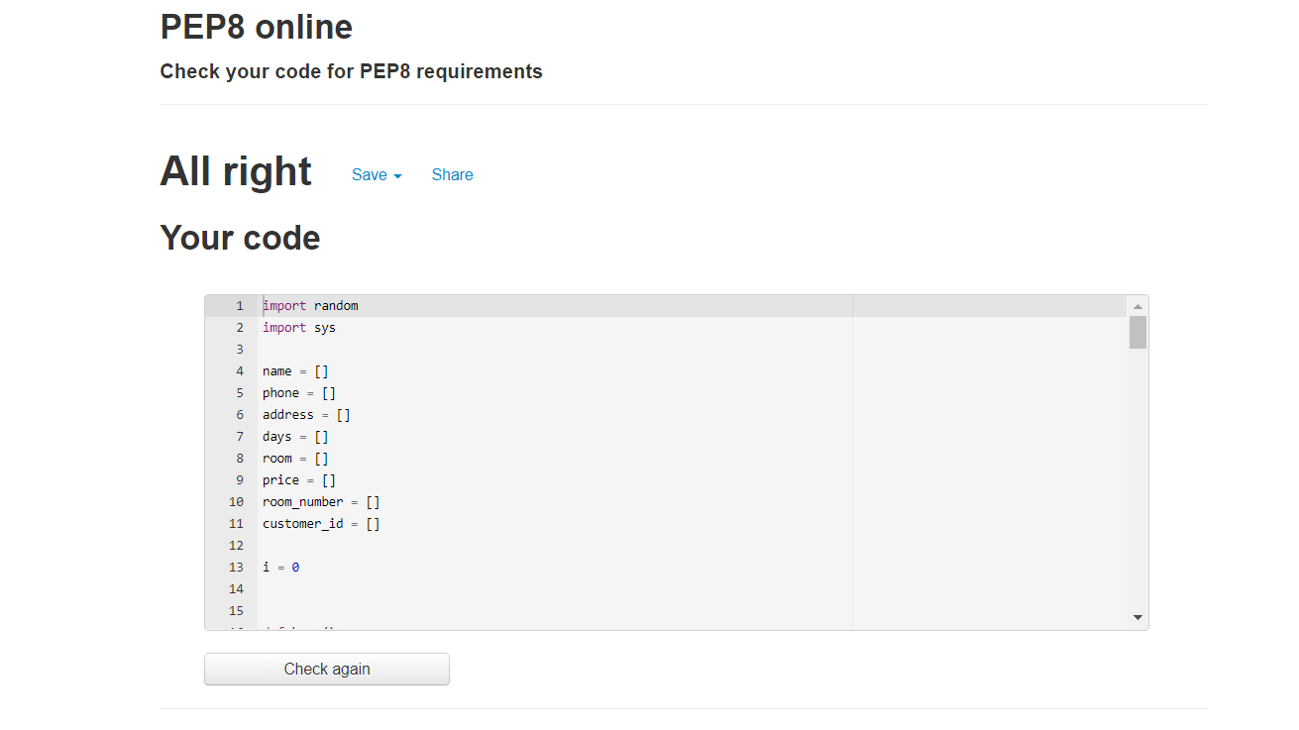

Figure 1: pep8 Activity1

# ACTIVITY 2

## **2.1 Code**

|  |
| --- |
| import random |
|  | import sys |
|  | import re |
|  |  |
|  | i = 0 |
|  |  |
|  | # parent class 1 |
|  |  |
|  |  |
|  | class hotel: |
|  |  |
|  | def __init__(self): |
|  |  |
|  | self.name = [] |
|  | self.phone = [] |
|  | self.address = [] |
|  | self.days = [] |
|  | self.room = [] |
|  | self.price = [] |
|  | self.room_number = [] |
|  | self.customer_id = [] |
|  | # Function for booking |
|  |  |
|  | def booking(self): |
|  |  |
|  | global i |
|  | # input details |
|  | print("\t\tRoom Booking") |
|  | print("\t-------------------") |
|  | n = str(input("\tEnter Name\t")) |
|  | while 1: |
|  | ph = str(input("\tEnter phone number\t")) |
|  | # regular expression to match phone number |
|  | reg = re.match("[1-9]{10}", ph) |
|  | print("\n\t", reg) |
|  | if reg is not None: |
|  | break |
|  | print("\n\tInvalid mobile number") |
|  | a = str(input("\tEnter address\t")) |
|  | d = int(input("\tEnter number of days\t")) |
|  | self.name.append(n) |
|  | self.phone.append(ph) |
|  | self.address.append(a) |
|  | self.days.append(d) |
|  |  |
|  | print("\nSelect Room Type") |
|  | print("\n 1. standard non AC - Rs. 3000") |
|  | print("\n 2. standard AC - Rs. 3500") |
|  | print("\n 3. 3-Bed non AC - Rs. 4000") |
|  | print("\n 4. 3-Bed AC - Rs. 4500") |
|  | ch = int(input("Enter your choice\t")) |
|  |  |
|  | if ch == 1: |
|  | self.room.append('standard non AC') |
|  | print("\n room type - standard non AC") |
|  | self.price.append(3000) |
|  | print("\n price : Rs. 3000") |
|  | elif ch == 2: |
|  | self.room.append('standard AC') |
|  | print("\n room type - standard non AC") |
|  | self.price.append(3500) |
|  | print("\n price : Rs. 3500") |
|  | elif ch == 3: |
|  | self.room.append('3 - Bed non AC') |
|  | print("\n room type - standard non AC") |
|  | self.price.append(4000) |
|  | print("\n price : Rs. 4000") |
|  | elif ch == 4: |
|  | self.room.append('3-Bed AC') |
|  | print("\n room type - standard non AC") |
|  | self.price.append(4500) |
|  | print("\n price : Rs. 4500") |
|  | else: |
|  | print("wrong Entry") |
|  | # allocating room no and id |
|  | room_n = random.randrange(99)+100 |
|  | cust_id = random.randrange(99)+1000 |
|  | while room_n in self.room or cust_id in self.customer_id: |
|  | room_n = random.randrange(99)+100 |
|  | cust_id = random.randrange(99)+1000 |
|  | print("\t\t\t***ROOM BOOKED SUCCESSFULLY***\n") |
|  | print("Room No. - ", room_n) |
|  | print("Customer Id - ", cust_id) |
|  | self.room_number.append(room_n) |
|  | self.customer_id.append(cust_id) |
|  | i = i+1 |
|  | n = int(input("0-BACK\n ->")) |
|  | if n == 0: |
|  | self.home() |
|  | else: |
|  | exit() |
|  | # function for calculating bill |
|  |  |
|  | def payment(self): |
|  |  |
|  | ph = str(input("Phone Number: ")) |
|  | global i |
|  | f = 0 |
|  |  |
|  | for n in range(0, i): |
|  | if ph == self.phone[n]: |
|  |  |
|  | f = 1 |
|  | print(" Payment") |
|  | print(" --------------------------------") |
|  | print("\n Amount: ", (self.price[n]*self.days[n])) |
|  | print("\n confirm payment") |
|  | print(" (y/n)") |
|  | ch = str(input("->")) |
|  | if ch == 'y' or ch == 'Y': |
|  | print("\n\n --------------------------------") |
|  | print(" Hotel AnCasa") |
|  | print(" --------------------------------") |
|  | print(" Bill") |
|  | print(" --------------------------------") |
|  | print(" Name: ", self.name[n], "\t\n Phone No.: ", |
|  | self.phone[n]) |
|  | print("\t\n Address: ", self.address[n], "\t") |
|  | print("\n Room Type: ", self.room[n]) |
|  | print("\t\n Room Charges: ", |
|  | self.price[n]*self.days[n], "\t") |
|  | print(" --------------------------------") |
|  | print("\n Total Amount: ", self.price[n]*self.days[n], |
|  | "\t") |
|  | print(" --------------------------------") |
|  | print(" Thank You") |
|  | print(" Visit Again :)") |
|  | print(" --------------------------------\n") |
|  | self.room_number.pop(n) |
|  | self.customer_id.pop(n) |
|  | self.room_number.insert(n, 0) |
|  | self.customer_id.insert(n, 0) |
|  | else: |
|  | print("\ninvalid phone number\t") |
|  | self.payment() |
|  | if f == 0: |
|  | print("Invalid Customer Id") |
|  |  |
|  | n = int(input("0-BACK\n ->")) |
|  | if n == 0: |
|  | self.home() |
|  | else: |
|  | exit() |
|  |  |
|  | # parent class 2 |
|  |  |
|  |  |
|  | class details: |
|  |  |
|  | def rooms_info(self): |
|  | print("\n\t\tRoom Details") |
|  | print("\n\t\t--------------------") |
|  | print("\n\t\t 1. Standard Non AC") |
|  | print("\n\t\t 2. Standard AC") |
|  | print("\n\t\t 3. 3 - Bed Non AC") |
|  | print("\n\t\t 4. 3 - Bed AC") |
|  | ch = int(input("Enter choice\t")) |
|  |  |
|  | if ch == 1: |
|  | print("\n\t\tSTANDARD NON-AC") |
|  | print("\t-----------------------------------------------") |
|  | print("\n\t\tRoom amenities include:1 Double Bed,Television,") |
|  | print("Telephone") |
|  | print("\n\t\tDouble-Door Cupboard,1 Coffee table with 2 sofa,") |
|  | print("Balcony and") |
|  | print("\n\t\tan attached washroom with hot/cold water.\n") |
|  | elif ch == 2: |
|  | print("\n\t\tSTANDARD NON-AC") |
|  | print("\n\t--------------------------------------------------") |
|  | print("Room amenities include: 1 Double Bed, Television,") |
|  | print("Telephone") |
|  | print("Double-Door Cupboard, 1 Coffee table with 2 sofa,") |
|  | print("Balcony and") |
|  | print("an attached washroom with hot/cold water +") |
|  | print("Window/Split AC.\n") |
|  | elif ch == 3: |
|  | print("\n\t\t3-Bed NON-AC") |
|  | print("\n\t----------------------------------------------------") |
|  | print("Room amenities include: 1 Double Bed + 1 Single Bed,") |
|  | print("Television") |
|  | print("Telephone, a Triple-Door Cupboard, 1 Coffee table") |
|  | print("with 2 sofa, 1") |
|  | print("Side table, Balcony with an Accent") |
|  | print("table with 2 Chair and an") |
|  | print("attached washroom with hot/cold water.\n") |
|  | elif ch == 4: |
|  | print("\n\t\t3-Bed AC") |
|  | print("\n\t------------------------------------------------------") |
|  | print("Room amenities include: 1 Double Bed + 1 Single Bed,") |
|  | print("Television") |
|  | print("Telephone, a Triple-Door Cupboard, 1 Coffee") |
|  | print("table with 2 sofa, ") |
|  | print("1 Side table, Balcony with an Accent table with 2") |
|  | print("Chair and an") |
|  | print("attached washroom with hot/cold") |
|  | print("water + Window/Split AC.\n\n") |
|  | else: |
|  | print("\n\t invalid entry") |
|  |  |
|  | ch = int(input("\n\t 0 - Back 1- Main Menu\t")) |
|  | if ch == 0: |
|  | self.rooms_info() |
|  |  |
|  | # child class of class 1 and class 2 |
|  |  |
|  |  |
|  | class menu(hotel, details): |
|  | # function for inputting user choice |
|  |  |
|  | def home(self): |
|  |  |
|  | print("\t\t\t\tWELCOME") |
|  | print("-------------------------------------------") |
|  | print("\n\t\t\t 1. Booking ") |
|  | print("\n\t\t\t 2. Payment") |
|  | print("\n\t\t\t 3. Rooms_info") |
|  | print("\n\t\t\t 4. Exit") |
|  | ch = int(input("Enter Choice\t")) |
|  | if ch == 1: |
|  | self.booking() |
|  | elif ch == 2: |
|  | self.payment() |
|  | elif ch == 3: |
|  | self.rooms_info() |
|  | else: |
|  | sys.exit(0) |
|  |  |
|  | a = menu() |
|  | while 1: |
|  | a.home() |

## **2.2 Pep8 Online Screenshot**

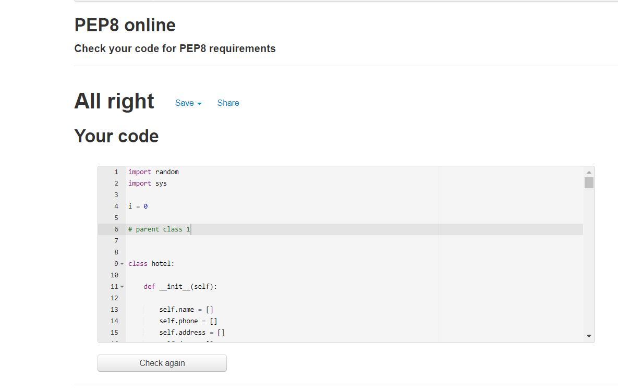

Figure 2: pep8 Activity 2